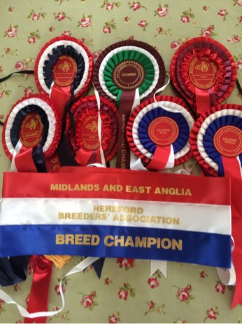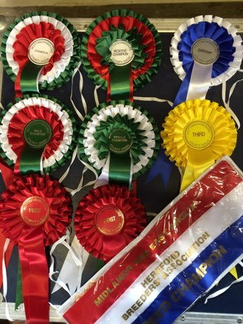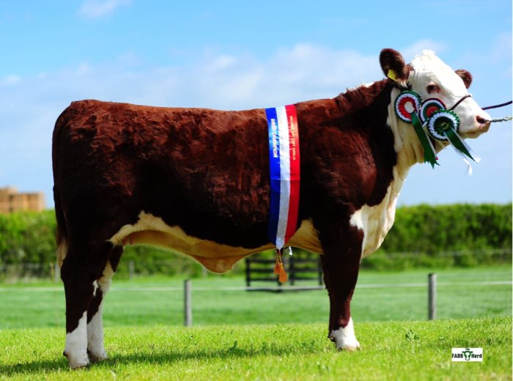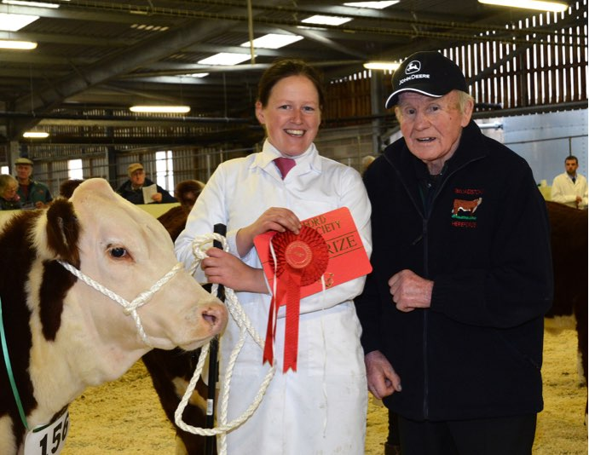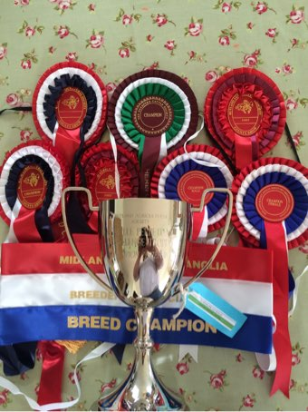

# 2015 Show Results

Nottingham County Show- Breed Champion, Female Champion, Reserve Breed Champion.

Rutland County Show- Breed Champion, Female breed Champion.

Suffolk Show- Reserve Breed Champion, Female Champion, Reserve Female Champion.

Smithfield Winter Fair- Reserve Champion Crossbred Native Steer.

National Hereford Calf Show Shropshire- First in Heifer Class, Second in Heifer Class.

www

Fabb Herd Polled Herefords 2015